Catalog Hackathon :

**Gudla Vineela – VU21CSEN0100510**

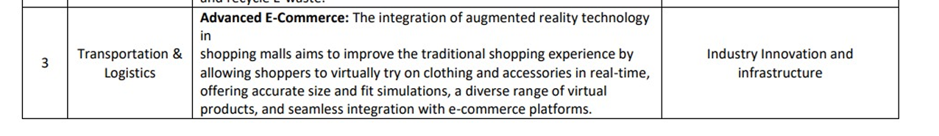

Output:1

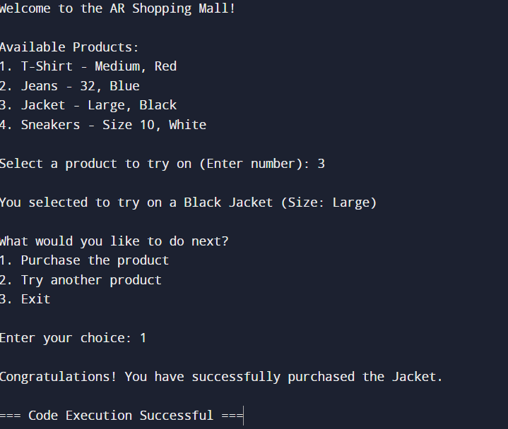

Output:2

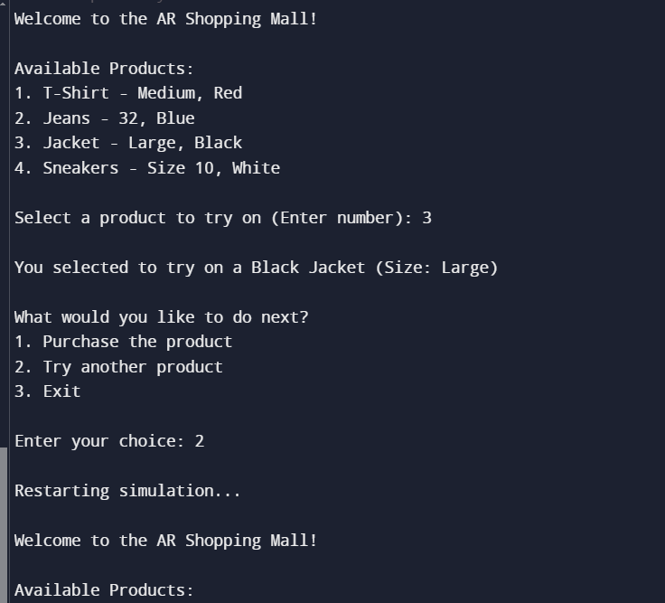

Output:3

